Design Document for PAR Dashboard

USA Health

Michael Banks, Joseph German,

Skylar Love, David McNair II

The Final Four

CIS 497

Spring 2025

# Summary

The USA Health IT Inventory PAR Dashboard will be created using C#, ASP.NET, React JS Rest API, and Entity Framework. Databases consist of our new PAR DB, which contains items, PAR rules, PAR notes, users, categories, subcategories, and roles. We also have our mock IDEAL DB, a MS SQL Server mock of the actual US Health IT Inventory Azure IDEA DB. Users consist of Admins, Editors, and Viewers. Actions consist of Create and Edit Users, Create and Edit PAR Rules, Create PAR Note, Refresh Data, Read Data, See PAR Alerts, and Generate Reports. All of these actions correspond to an action an Admin, Editor, or Viewer can perform using the React JS Web Application which performs CRUD operations from/to our PAR DB using Entity Framework and/or Rest API. Permissions and their respective Use Cases are demonstrated in our Diagram USE CASE DIAGRAM. Our PAR DB Items table is populated with data pulled/refreshed from the IDEAL DB using Rest API. Essentially, our PAR DB and the IDEAL DB both connect to the C#/.NET backend, which also connects to the ASP.NET/React JS frontend Web application. Rest API and Entity Framework handle communication between our Data and our application. The entire project is intended to be transferable to Azure for integration into their real system.

The goal is for Admins, Editors, and Viewers to logon to the application to set PAR Rules for Items in the inventory system and then be alerted when items are not PAR. Users can also send Admins notes about PAR rules, i.e. if they notice deliveries have been taking longer than usual the last few times and recommend that PAR rule be adjusted to reflect that. Users will also have the ability to generate reports, and details on that are TBD.

**IDEAL**  – (IT Delivery, Equipment, & Asset Logistics) system

**Usage Rate** – The average number of IT assets consumed or assigned over a given period.

**Lead Time** – The time it takes to receive new assets once an order is placed.

**Safety Stock (10-20%)** – An additional buffer (10-20% of the calculated demand) to cover unexpected delays or spikes in usage.

**PAR** = (usage rate x lead time) + safety (10-20%)

# 

# Use Case Diagram

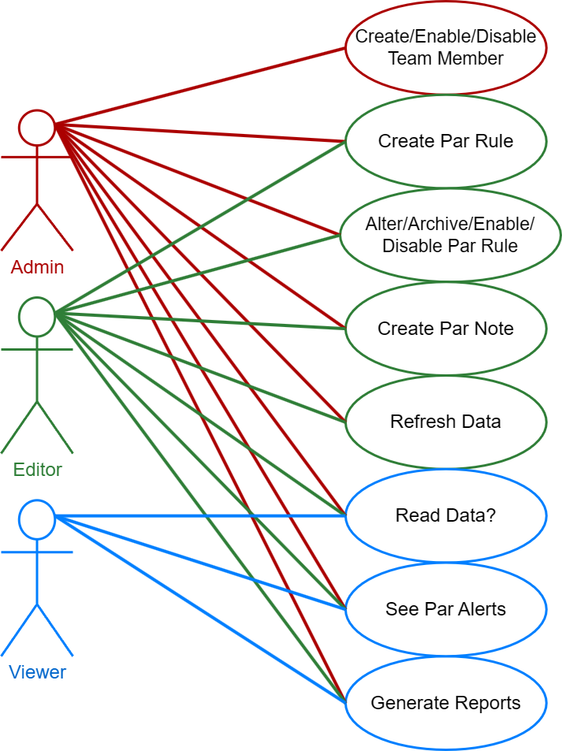

# Use Case Descriptions

## “Create/Enable/Disable Team Member”

| Use Case Name | Create Team Member |
| --- | --- |
| Description | Admins can add editors and viewers to the database via the application. Admins cannot add or alter other admins through the application. |
| Primary Actor | Admin |
| PreCondition | User must be logged in with an Admin level account. |
| PostConditions | A new user record is created in the database. |
| Flow of events | |
| Actor Action | System Response |
| 1. Admin needs to add a new User and grant them access to the application. The admin goes to the view that displays team member data and clicks “create new user” | 2. React JS Web front-end displays team member data, then onclick of button “create new team member”, displays a form of required data for creating a new user. |
| 3. Admin fills out the displayed form and hits save. | 4. System confirms the data is suitable / sanitized and stores data in the database. System displays a confirmation message. Details TBD. |
| Alternative Events | |
|  | 4. System finds data unsuitable for creating a new user record in the database. System notifies admin of error(s). System takes admin back to unsubmitted form. Details TBD. |
| 5. Admin retries from step 3. |  |

## “Create PAR Rule”

| Use Case Name | Create a PAR rule |
| --- | --- |
| Description | This use case describes the process of creating a new PAR rule. This rule will define a threshold for inventory items, allowing users with the appropriate privileges (access level) to set an item to maintain a minimum quantity. |
| Primary Actor | Admin/Editor |
| Preconditions | User logged in with correct access level. Item must exist. |
| Postconditions | A PAR rule record is created |
| Flow of events | |
| Actor Action | System Response |
| 1. Admin or Editor needs to create and assign a PAR Rule to an inventory item. Admin goes to PAR Rules display and selects “Create new PAR Rule” | 2. System displays PAR Rule table and ui elements such as buttons, Upon user selecting “Create New PAR Rule” button, displays a form for use to input PAR rule data. |
| 3. Admin fills out the displayed form and hits save. | 4. System confirms the data is suitable / sanitized and stores data in the database. System displays a confirmation message. Details TBD. |
| Alternative Events | |
|  | 4. System finds data unsuitable for creating a new user record in the database. System notifies admin of error(s). System takes admin back to unsubmitted form. Details TBD. |
| 5. Admin retries from step 3. |  |

## “Create PAR Note”

| Use Case Name | Create PAR note |
| --- | --- |
| Description | This use case describes the process of creating a PAR note. Users with the correct access level can create notes related to a specific PAR rule. |
| Primary Actor | Admin/Editor |
| Preconditions | User logged in with correct access level. PAR Rule or Item exists. |
| Postconditions | PAR Rule and/or Item will have an associated PAR note in the database which can be easily viewed by all users. |
| Flow of events | |
| Actor Action | System Response |
| 1. Admin or Editor needs to create a PAR note for an existing PAR rule or an item that is missing an active PAR rule. Admin goes to PAR Notes screen and selects “Create a new PAR note” | 2. System displays PAR Notes screen, then selects a PAR Note form for the user to fill out. |
| 3. Admin fills out the displayed form and hits save. | 4. System confirms the data is suitable / sanitized and stores data in the database. System displays a confirmation message. Details TBD. |
| Alternative Events | |
|  | 4. System finds data unsuitable for creating a new user record in the database. System notifies admin of error(s). System takes admin back to unsubmitted form. Details TBD. |
| 5. Admin retries from step 3. |  |

# 

# 

# 

# ERD

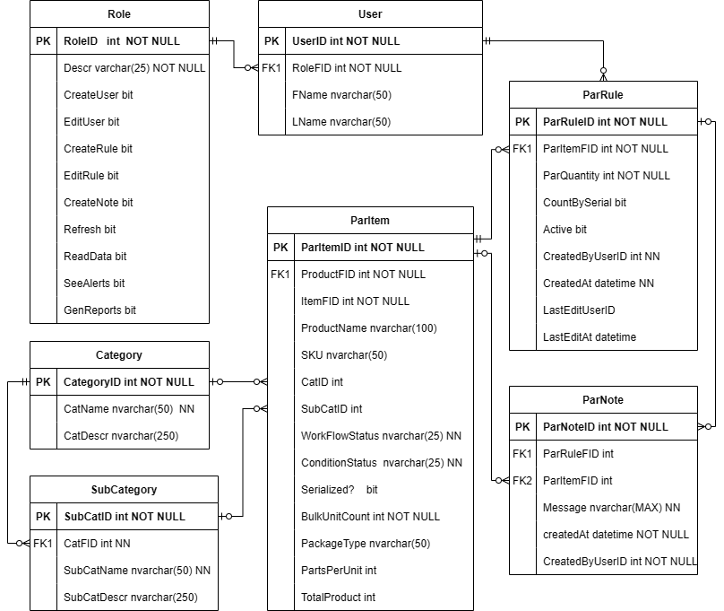

# Sequence Diagrams

## Use Case “Create a PAR Rule”:

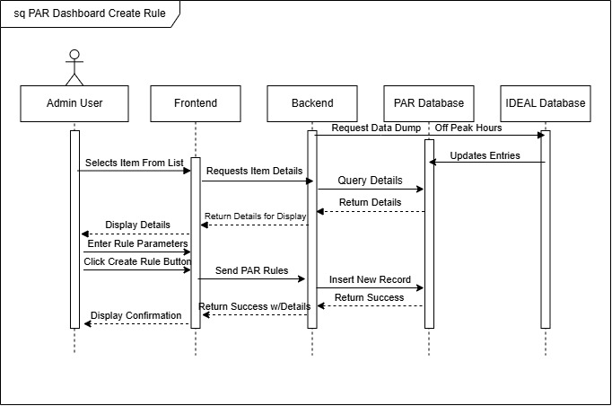

# Client Signature: **____________________________**